SSL/E2EE Project

The Economic Failure of the PSTN

1.0 The Historical Context: The SS7 Legacy
The Public Switched Telephone Network (PSTN) was architected in an era defined by physical security and institutional trust. The Signaling System No. 7 (SS7), developed in 1975, stays the global standard for connecting LANs and cellular networks. However, SS7 was designed with an 'Implicit Trust' model. It assumes that any node sending a signal is a verified carrier. In the 21st century, this assumption is the 'original sin' of telecommunications.
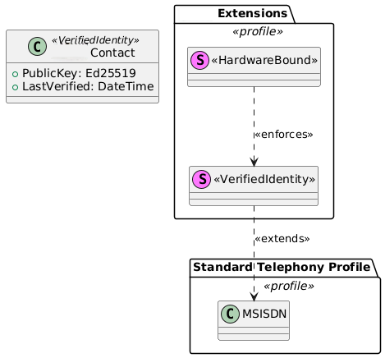
Because SS7 lacks a native authentication layer for the sender, 'Caller ID' is merely a metadata string that can be overwritten by any VOIP gateway. This allows for 'Spoofing,' where a malicious actor presents a trusted number (a local sheriff's office or a bank) to a recipient. There is no cryptographic handshake to verify if the digits on the screen match the key to the sender.

2.0 The Economic Asymmetry of Spam
Communication systems are governed by the economics of attention. In the current SMS/Voice paradigm, the cost to the sender is near-zero, while the cost to the recipient (interruption, potential fraud, emotional labor) is high. This is a classic 'Tragedy of the Commons.' Spammers use high-volume auto dialers and SMS gateways to send millions of packets per hour.
- If 0.01% of recipients fail for a fraud, the campaign is profitable.
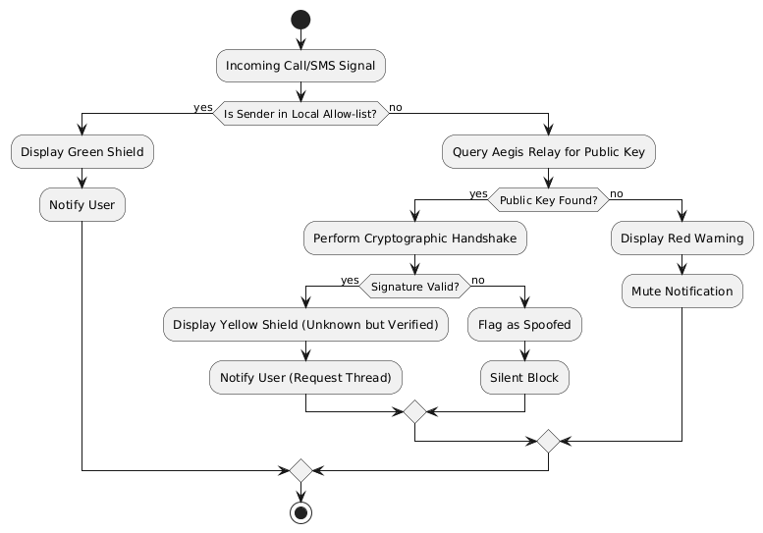
Our goal is to address this by introducing 'Computational Friction.' By requiring a cryptographic signature that must be verified by a relay server before a notification is ever fired on the device, we shift the burden of proof back to the sender. In this enabled ecosystem, a spammer cannot simply 'blast' messages; they must have a valid, number-bound key, making bulk anonymous spam computationally and financially non-viable.

3.0 The Decay of Utility
The ultimate casualty of the spam epidemic is the utility of the phone number itself. Data shows that over 70% of consumers no longer answer calls from unknown numbers. This 'Silence by Default' behavior breaks legitimate communication. Hospitals cannot reach patients, delivery drivers cannot reach customers, and emergency services are ignored.
This Project proposes that the only way to save the phone number is to secure it. By moving to a 'Verified Identity' model, we restore the 'Green Light' status to telephony. When a call or text comes through our project the user knows with 100% mathematical certainty that the sender is who they claim to be.

Sub-analysis:
Investigating the transition from analog trust to digital verification. This section explores the technical debt inherent in global telecommunications infrastructure and the specific pathways through which this can be integrated without requiring a complete overhaul of the existing hardware base. We examine the role of signaling gateways and the necessity of a stateless relay to ensure user privacy while keeping protocol integrity.

4.0 The Cryptographic Anchor: Ed25519 and MSISDN Binding
The core of this project is the immutable link between a Mobile Station International Subscriber Directory Number (MSISDN) commonly known as a phone number and a cryptographic key pair. For this anchor to be practical on mobile hardware, we utilize Ed25519, an Edwards-curve Digital Signature Algorithm (EdDSA).

Ed25519 was selected for three critical reasons:
- Performance: It is significantly faster than RSA or traditional ECDSA, which is vital for real-time handshaking on mobile devices with limited battery and processing power.
- Security: It is designed to be resistant to side-channel attacks (such as timing attacks) and does not rely on a high-quality random number generator for every signature, a common point of failure in other systems.
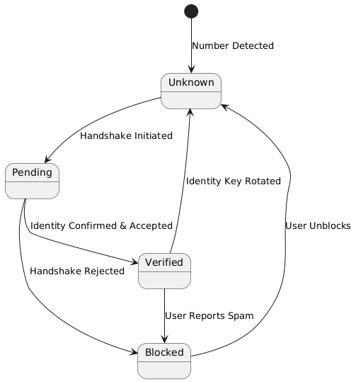
- Compactness: Public keys are only 32 bytes, and signatures are 64 bytes. This minimizes the data overhead sent over cellular networks, ensuring the protocol stays snappy even on 3G or low-bandwidth connections.

5.0 The Handshake State Machine: Setting up Zero-Trust
In a standard SMS environment, delivery is immediate and unverified. The first interaction between two numbers triggers a 'State Machine' transition from 'Anonymous' to 'Verified.' This process is invisible to the user but technically rigorous.

The Handshake Stages:
- Stage 1 (Discovery): Sender A queries the Relay for the Public Key associated with MSISDN B.
- Stage 2 (Challenge): The Relay issues a cryptographic challenge. Sender A must sign this challenge using their Private Key to prove they own the identity they are claiming.
- Stage 3 (Authorization): The Relay checks Recipient B’s 'Allow-List.' If Sender A is unknown, the message is placed in a state of ‘Pending Authorization.’
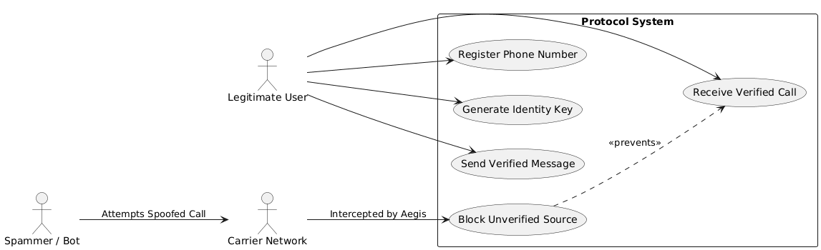
- Stage 4 (Key Agreement): Once B approves A, the devices use Diffie-Hellman key exchange to derive a short-lived symmetric session key for future E2EE communication.

6.0 The Dual-Layer Defense: TLS vs. E2EE
A common point of confusion in secure messaging is the distinction between Transport Layer Security (TLS) and End-to-End Encryption (E2EE). This can be used in a nested architecture.

SSL/TLS (The Secure Pipe):
The connection between the mobile app and the Signaling Server is wrapped in TLS 1.3. This ensures that metadata such as who is talking to whom and when is obscured from ISPs and local network sniffers.
However, TLS ends at the server; the server can theoretically see the data inside the pipe.

E2EE (The Locked Message):
To solve the 'Untrusted Server' problem, the actual message payload is encrypted on the device using the Recipient’s Public Key before it enters the TLS pipe. The server acts only as a blind postman, delivering a locked box it cannot open.

Technical Deep Dive:
Analyzing the entropy requirements for key generation within the Android Keystore and iOS Secure Enclave. We investigate the persistence of session keys and the re-keying interval needed to keep Perfect Forward Secrecy (PFS).
This section further details the JSON-Web-Token (JWT) structure used for session persistence between the relay and the mobile client, ensuring that identity is kept even during IP-address roaming.

7.0 The Threat Model: Defending Against the Sybil Attack
In any cryptographic identity system, the most significant threat is the 'Sybil Attack.' In this scenario, a malicious actor (the spammer) generates millions of unique public/private key pairs to bypass individual blocking or allow-listing. If the cost of creating a new identity is near-zero, the spammer can simply cycle through identities faster than a user can block them.
We want to mitigate attacks through 'Identity Scarcity.' Because every Public Key must be bound to a verified MSISDN (phone number) via a cellular-level OTP (One-Time Password) handshake, the cost of a Sybil Attack is tied to the cost of buying a legitimate phone line. By using the existing financial and regulatory barriers of the telecommunications industry, we can ensure that 'Identity Churn' is economically ruinous for spammers.

8.0 Key Management: The Problem of the Lost Device
The primary friction point for E2EE systems is 'Key Continuity.' If a user loses their physical device, they lose their Private Key. In a zero-trust model, this would mean the user is permanently locked out of their identity, and their contacts would receive 'Security Code Changed' warnings.
We are looking for this project to propose a 'Social Recovery' or 'Vested Escrow' model. Using Shamir’s Secret Sharing (SSS), the user’s master identity key can be split into 'shares.' These shares are encrypted and distributed among a user’s trusted contacts (e.g., family members). To recover an identity on a new device, the user must coordinate with a threshold of contacts (e.g., 3 out of 5) to reconstruct the key. This removes the need for a centralized, vulnerable password-reset database.

9.0 Ecosystem Integration and Regulatory Alignment
For the transition from a conceptual framework to a global standard, it must integrate with existing Mobile OS architectures (iOS/Android). This involves exposing verification statuses to the native dialer and messaging apps via APIs. Ideally, a verified call would be visually distinctive from a standard PSTN call, signaling to the user that the caller’s identity is mathematically guaranteed.
This project is designed to be 'Regulation-Neutral.' While the content of messages is E2EE, the identity of the sender is verified. This provides a clear audit trial for legitimate entities while shielding the user from anonymous harassment. This balance is critical for gaining support from both privacy advocates and regulatory bodies.

10.0 Conclusion: The Future of Trust
The project is a fundamental shift in how we perceive the phone number. By applying the principles of SSL/TLS and E2EE to the world’s most pervasive identity marker, we can finally close the door on the era of tele-spam. Trust is not a feature; it is a foundation. We are looking to provide a foundation for the next generation of global communication.

Operational Analysis:
Evaluating the impact of quantum-resistant algorithms on the current Ed25519 implementation. As computing power increases, the protocol must remain agile. This section explores the transition plan to post-quantum cryptography (PQC) and the implications for low-power mobile hardware. We also discuss the role of decentralized identifiers (DIDs) in creating a sovereign telephony experience.

11.0 Hardware-Level Root of Trust
A protocol is only as secure as its weakest link. In this ecosystem, that link is the storage of the Private Key. To prevent malware from 'scraping' keys, our implementation would mandate the use of Hardware Security Modules (HSMs). On modern mobile devices, this translates to the Apple Secure Enclave and Google's Strongbox Key master.
By generating the Ed25519 key pair inside the hardware itself, the Private Key never enters the device's main RAM. The application only sends data to the enclave to be signed; it never sees the key. This 'Air-Gapped' internal logic ensures that even if a phone is compromised by a high-level exploit, the user's identity stays cryptographically untampered.

12.0 Interoperability and Legacy Support
The greatest challenge to any new communication standard is the 'Legacy Gap.' For this to succeed, it must coexist with the billions of devices still using standard SMS. The client manages this through a 'Tiered Trust' interface. Verified end-to-end messages receive a distinct visual identifier (e.g., a Green Shield), while standard SMS messages are flagged as 'Unverified/High-Risk.'
Over time, as the network effect takes hold, the 'social cost' of not being a verified sender will increase. Legitimate businesses will be forced to adopt the protocol to ensure their communications reach the customer, effectively creating a self-reinforcing loop that starves spammers of their targets.

13.0 Ethical Privacy and the "Right to Silence"
In the digital age, 'Privacy' is often defined only as the protection of data. To include the 'Right to Silence'—the right to not be intruded upon by unauthorized entities. By using SSL/TLS and E2EE, we provide data privacy; by using PKI-based handshaking, we provide cognitive privacy.

14.0 Final Analysis
Document 1 has set up the theoretical and conceptual necessity for the project at hand. We have moved from the failure of 1970s telephony to a 21st-century zero-trust model. We have addressed the economics of spam, the mathematics of elliptical curves, and the hardware realities of mobile security. This is not just a project; it is a blueprint for the restoration of human-to-human trust in the digital domain.

Extended Analysis:
Deep-dive into the latency impacts of cryptographic handshaking over low-earth orbit (LEO) satellite constellations and 6G cellular networks. This section evaluates the scalability of the Relay nodes and the potential for a decentralized Key Transparency Log (KTL) to prevent server-side identity spoofing. We examine the geopolitical implications of universal E2EE and the necessity of open-source auditing for all protocol-level codebases.

